1. What is the IP address and TCP port number used by the client computer (source) that is transferring the file to gaia.cs.umass.edu? To answer this question, it’s probably easiest to select an HTTP message and explore the details of the TCP packet used to carry this HTTP message, using the “details of the selected packet header window” (refer to Figure 2 in the “Getting Started with Wireshark” Lab if you’re uncertain about the Wireshark windows.

IP Address: 192.168.1.102

TCP Port Number(client computer): 1161



2. What is the IP address of gaia.cs.umass.edu? On what port number is it sending and receiving TCP segments for this connection?

IP Address: 128.119.245.12

TCP Port Number(gaia.cs.umass.edu): 80



3. What is the IP address and TCP port number used by your client computer (source) to transfer the file to gaia.cs.umass.edu?

IP Address: 10.248.105.226

TCP Port Number: 55657



4. What is the sequence number of the TCP SYN segment that is used to initiate the TCP connection between the client computer and gaia.cs.umass.edu? What is it in the segment that identifies the segment as a SYN segment?

Sequence Number of TCP SYN segment: 0 (RAW: 232129012)

In the segment, there is a flag which identifies the segment as a SYN segment.

5. What is the sequence number of the SYNACK segment sent by gaia.cs.umass.edu to the client computer in reply to the SYN? What is the value of the Acknowledgement field in the SYNACK segment? How did gaia.cs.umass.edu determine that value? What is it in the segment that identifies the segment as a SYNACK segment?

The sequence number of the SYNACK segment sent by gaia.cs.umass.edu is 0(raw: 883061785)

The value of the Acknowledgement field in the SYNACK segment is 1(raw: 232129013)

‘gaia.cs.umass.edu’ determined that value by using flags represented in hexadecimals.

In SYNACK segment, there are flags which identifies the segment as a SYNACK segment.

6. What is the sequence number of the TCP segment containing the HTTP POST command? Note that in order to find the POST command, you’ll need to dig into the packet content field at the bottom of the Wireshark window, looking for a segment with a “POST” within its DATA field.

The sequence number of the TCP segment containing HTTP POST is the cumulative sum of the length of previous segments.

7. Consider the TCP segment containing the HTTP POST as the first segment in the TCP connection. What are the sequence numbers of the first six segments in the TCP connection (including the segment containing the HTTP POST)?

At what time was each segment sent? When was the ACK for each segment received? Given the difference between when each TCP segment was sent, and when its acknowledgement was received, what is the RTT value for each of the six segments?

What is the EstimatedRTT value (see Section 3.5.3, page 242 in text) after the receipt of each ACK? Assume that the value of the EstimatedRTT is equal to the measured RTT for the first segment, and then is computed using the EstimatedRTT equation on page 242 for all subsequent segments.

Note: Wireshark has a nice feature that allows you to plot the RTT for each of the TCP segments sent. Select a TCP segment in the “listing of captured packets” window that is being sent from the client to the gaia.cs.umass.edu server. Then select: Statistics->TCP Stream Graph- >Round Trip Time Graph.

The sequence numbers of first six segments in the TCP connection are 0, 1, 1, 566, 2026, 3486.

(Note: Time Display is Seconds since Beginning of Capture)

<Sequence Number: Time-segment sent>

0: 0s

1: 0.023172

1: 0.026477

566: 0.041737

2026: 0.054026

3486: 0.054690

<Sequence Number: Time-ACK Received>

0: 0.023172s

1: -

1: -

566: 0.053937s

2026: 0.077294s

3486: 0.124085s

<Sequence Number : RTT>

0: 0.0023172s

1: -

1: -

566: 0.0122s

2026: 0.023268s

3486: 0.069395s

<Sequence Number: Estimated RTT> (Note: )

0: 0.0012172s

1: -

1: -

566: 0.0076744188s

2026: 0.163763665s

3486: 0.298418207s

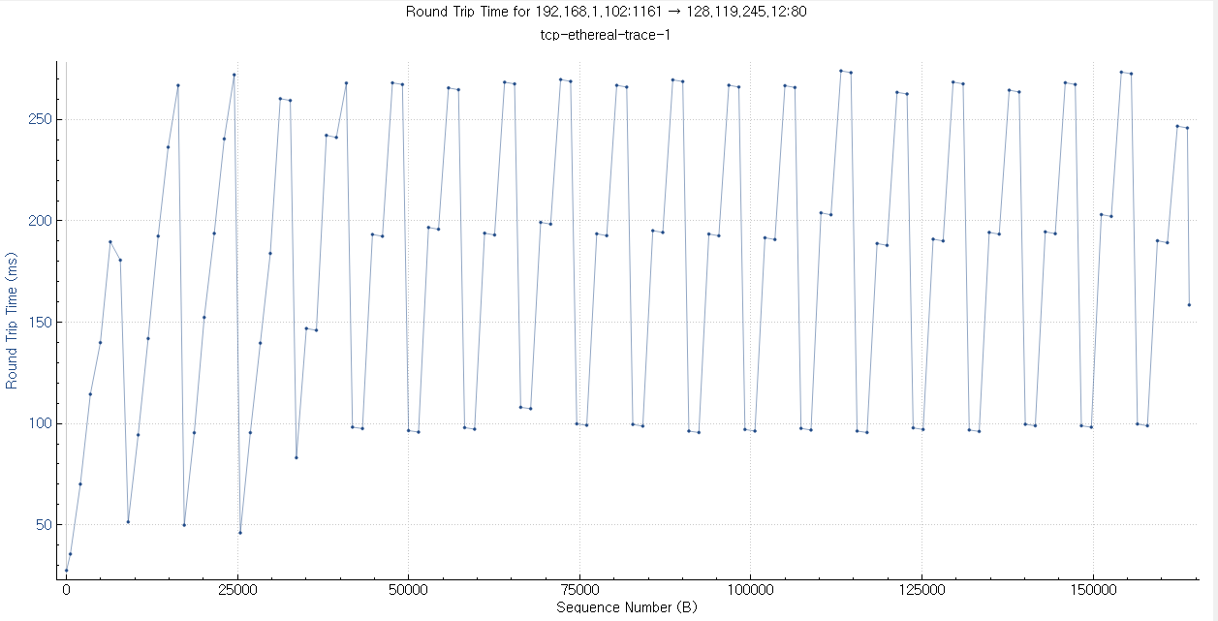

8. What is the length of each of the first six TCP segments?

<Sequence Number: Length (bit)>

0: 0

1: 0

1: 565

566: 1460

2026: 1460

3486: 1460

9. What is the minimum amount of available buffer space advertised at the received for the entire trace? Does the lack of receiver buffer space ever throttle the sender?

The minimum amount of available buffer space is 5840 bytes.

The lack of receiver buffer space throttled the sender. Whenever, the buffer space is determined too small for sender, the sender sent packet which length was zero.

10. Are there any retransmitted segments in the trace file? What did you check for (in the trace) in order to answer this question?

There were no retransmitted segments in the trace file. Although, there was a duplicate sequence number of 1, the first 1 had length of 0 so that there is no change on the next sequence number. Except this case, there was no duplicated sequence number from the sender side. Through these reasons, there was no retransmitted segment in the trace file.



11. How much data does the receiver typically acknowledge in an ACK? Can you identify cases where the receiver is ACKing every other received segment (see Table 3.2 on page 250 in the text).

The receiver typically acknowledges 20 bytes in an ACK.

The receiver can acknowledge every other received segment by using the header.

12. What is the throughput (bytes transferred per unit time) for the TCP connection? Explain how you calculated this value.

The throughput for the TCP connection is 16812.0 bytes per second. The reason is that the smallest bandwidth for the TCP connection was 54 bytes, and it took 0.003212 seconds so that the throughput for the TCP connection is around 17Kbyte/s.



13. Use the Time-Sequence-Graph(Stevens) plotting tool to view the sequence number versus time plot of segments being sent from the client to the gaia.cs.umass.edu server. Can you identify where TCP’s slowstart phase begins and ends, and where congestion avoidance takes over? Comment on ways in which the measured data differs from the idealized behavior of TCP that we’ve studied in the text.

The TCP’s slow-start phase begins where the vertical edge of the graph starts, and ends where the vertical edge of the graph ends. (The orange circled area in the figure below.)

The data differs the idealized behavior of TCP which we handled in the class. The Stevens plotting showing the behavior like a stair, and the ideal behavior handled in class was oscillating between the maximum Window size and its half size. The reason of both plotting showing a different behavior is that Stevens plotting is setting the entire sequence number of segments and time as a variable, and the ideal behavior of TCP is setting the window size and time as a variable. Thus, these are the reason why each of the plotting shows different behavior.

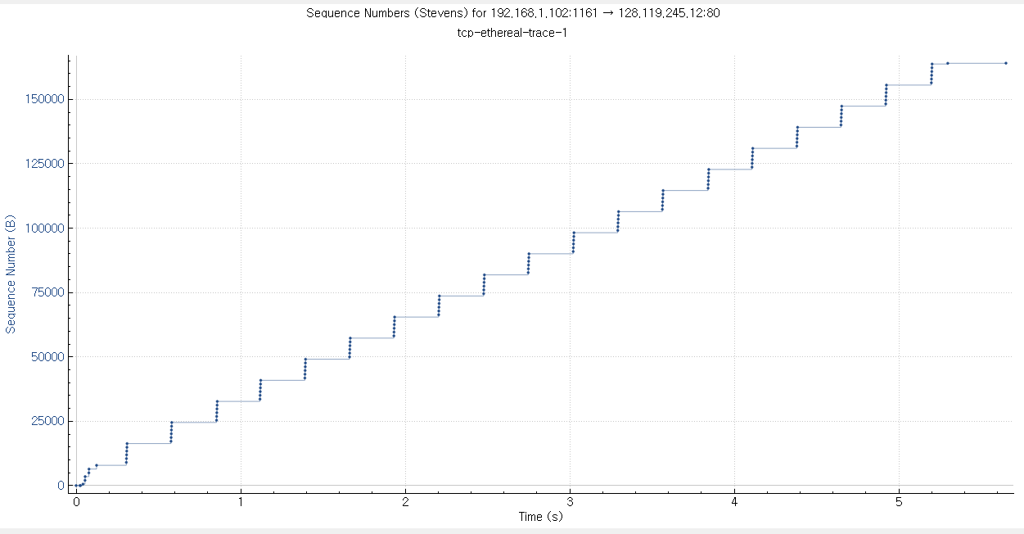

14. Answer Question 13 for the trace that you captured when you transferred a file from your own computer to gaia.cs.umass.edu

The TCP’s slow-start phase begins where the vertical edge of the graph starts, and ends where the vertical edge of the graph ends. (The orange circled area in the figure above.)

The data differs the idealized behavior of TCP which we handled in the class. The Stevens plotting showing the behavior like a stair, and the ideal behavior handled in class was oscillating between the maximum Window size and its half size. The reason of both plotting showing a different behavior is that Stevens plotting is setting the entire sequence number of segments and time as a variable, and the ideal behavior of TCP is setting the window size and time as a variable. Thus, these are the reason why each of the plotting shows different behavior. Furthermore, my actual trace is different because there was less communication between sender and receiver than the pre-record file. This can be expected that the size of segment and throughput of TCP connection is much more larger than the pre-record trace.